📄 Lab 9 Documentation
Dataset Loading & Data Exploration

1. Introduction
The purpose of this lab was to select any dataset from Kaggle and perform basic data analysis steps, including loading the dataset into the environment and exploring its structure. Data Exploration helps in understanding the dataset before performing any further processing or modeling.

2. Data Loading / Reading
In this step, the dataset (CSV or JSON format) is imported into a DataFrame.
The goal of loading the data is to make it available for analysis in a structured form.
A DataFrame allows easy viewing, filtering, cleaning, and further statistical operations.
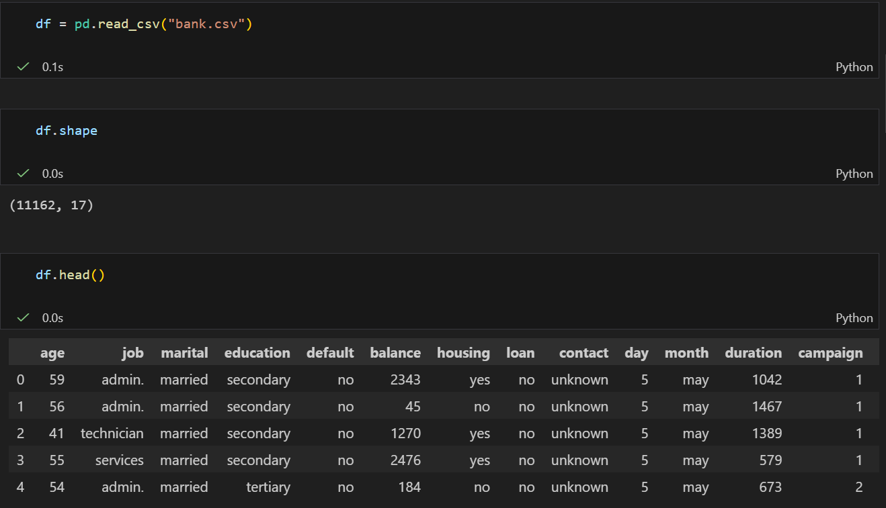

3. Data Exploration (EDA)
a) Checking Dataset Size
The first step of exploration is to check how many rows and columns the dataset contains.
This helps understand the scale and complexity of the data.
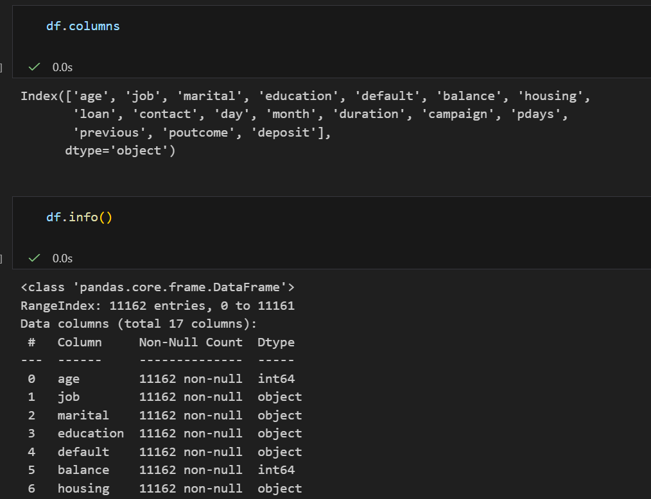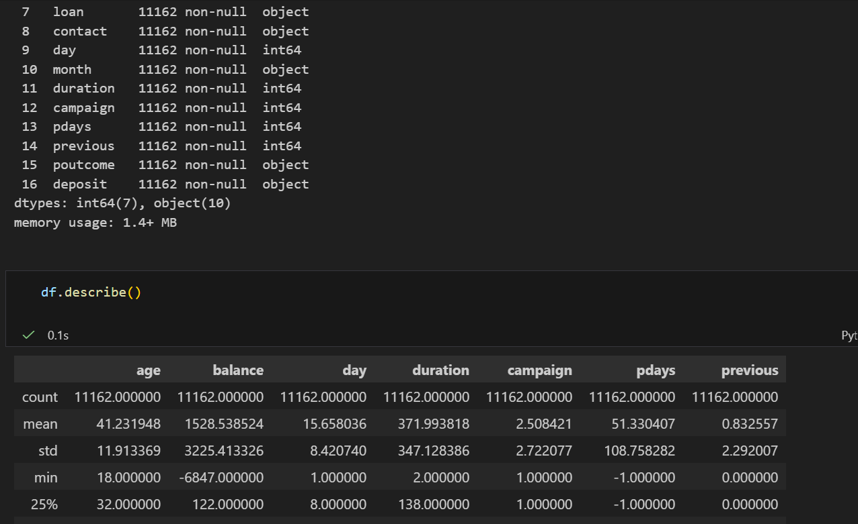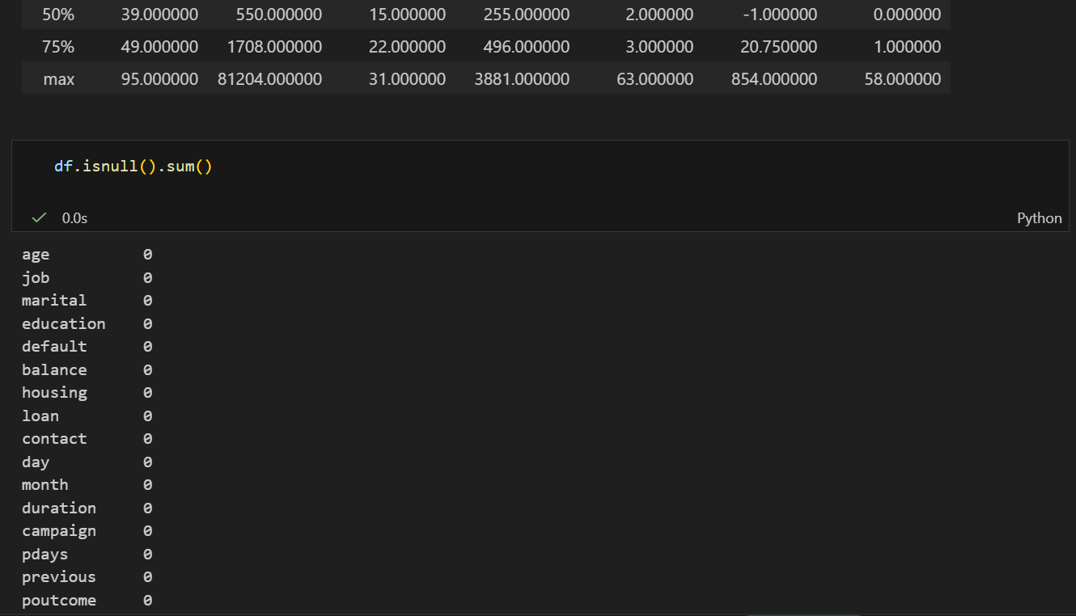

b) Viewing the First Few Records
The first few rows of the dataset are examined to get an idea of:
- What kind of values each column holds
- Whether the data is clean
- If there are formatting errors
This gives a quick preview of the dataset.
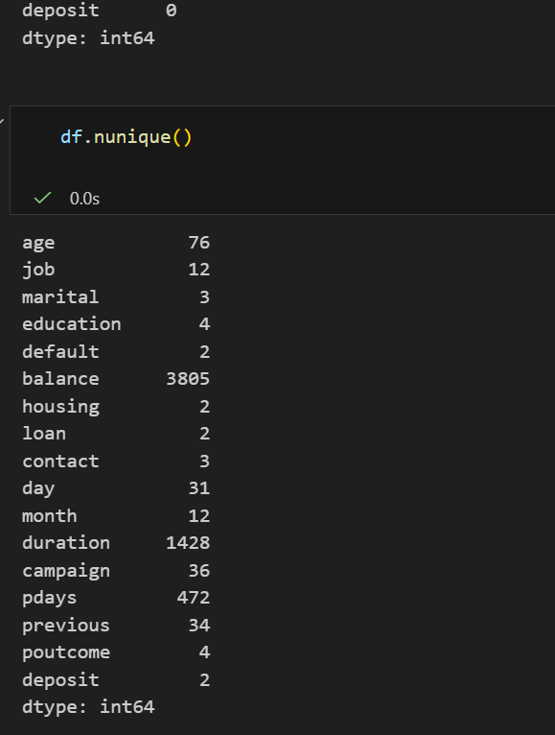

c) Displaying Column Names
This step lists all the column names.
It helps identify the features available in the dataset and how they might be used for analysis.

d) Dataset Information
The dataset information includes:
- Data types of each column
- Number of non-null values
- Overall structure of the data
This step is important for detecting issues such as missing values or wrong data types.

e) Statistical Summary
Statistical summary provides basic numerical statistics such as:
- Mean
- Standard deviation
- Minimum and maximum values
- Quartiles
These statistics help understand the distribution of numerical features.

f) Checking Missing Values
Each column is checked for missing or null values.
This step is essential for identifying data quality problems and planning the cleaning process.

g) Counting Unique Values
Unique value count shows how many distinct values are present in each column.
This helps in understanding data diversity and is especially useful for categorical features.

4. Conclusion
In this lab, a dataset from Kaggle was successfully loaded and thoroughly explored.
The exploration provided a clear understanding of the dataset's structure, quality, missing values, and statistical characteristics. This foundational analysis is essential before performing data cleaning, visualization, or machine learning tasks.

